Figure 1. Boundaries of the two strata (“West” and “East”) used for analysis of continental Blackpoll Warbler population trends from long-term migration monitoring data. Location labels for migration monitoring stations included in analysis are colour coded to indicate data from pre-breeding migration only (green), post-breeding (blue) or both seasons (purple).

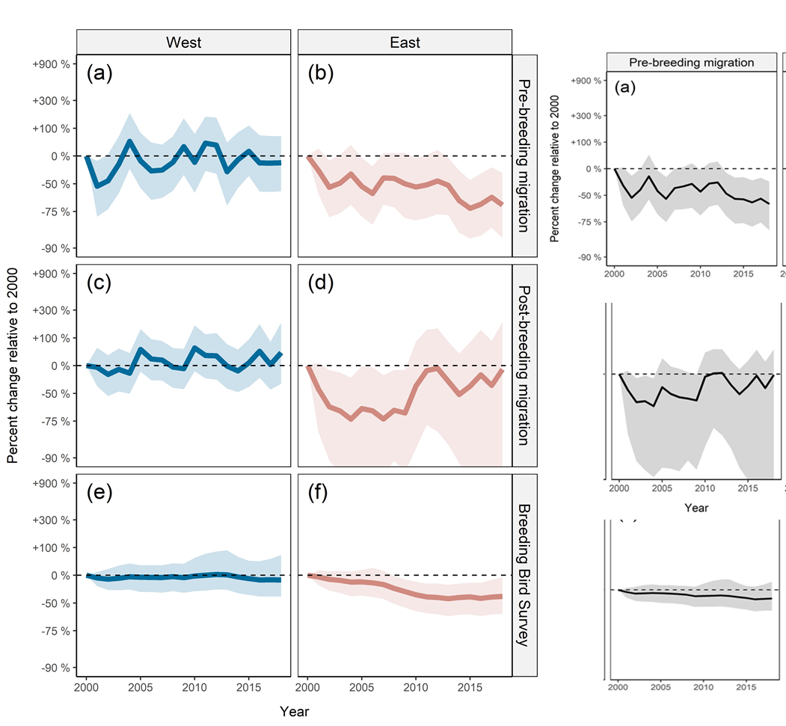

Continental

Figure 2. Estimated population trajectories of Blackpoll Warbler in East and West strata and continentally from 2000 to 2018, based on analysis of pre-breeding migration (top row), post-breeding migration (middle row), and North American Breeding Bird Survey (bottom row). Strata boundaries are illustrated in Figure 1.